**Project Design Phase-II**

**Data Flow Diagram & User Stories**

|  |  |
| --- | --- |
| Date | 10 October 2022 |
| Team ID | PNT2022TMID10221 |
| Project Name | Hazardous Area Monitoring for Industrial Plant powered by IoT |
| Maximum Marks | 4 Marks |

**Data Flow Diagrams:**

A Data Flow Diagram (DFD) is a traditional visual representation of the information flows within a system. A neat and clear DFD can depict the right amount of the system requirement graphically. It shows how data enters and leaves the system, what changes the information, and where data is stored.

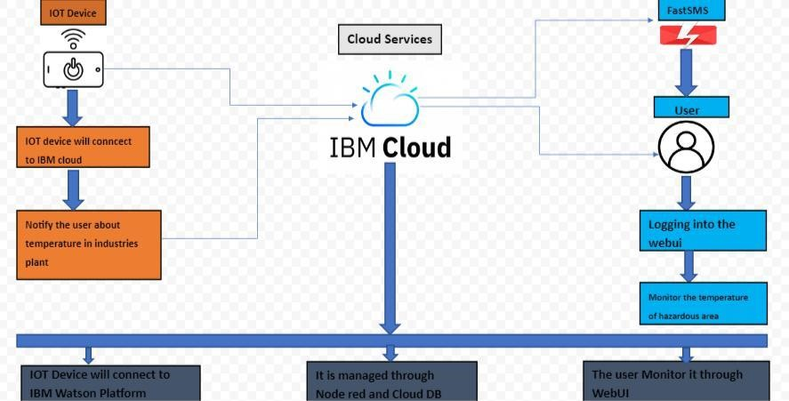

**User Stories**

Use the below template to list all the user stories for the product.

|  |  |  |  |  |  |  |
| --- | --- | --- | --- | --- | --- | --- |
| **User Type** | **Functional** | **User Story** | **User Story / Task** | **Acceptance criteria** | **Priority** | **Release** |
|  | **Requirement (Epic)** | **Number** |  |  |  |  |
| Customer | Registration | USN-1 | As an Industrial Owner, I can register | I can access my | High | Sprint-1 |
| (Industrial |  |  | into the application by entering email | account / dashboard |  |  |
| Owner) |  |  | & password |  |  |  |
|  | Data Modules | USN-2 | As an Industrial Owner, I can get | I can receive | High | Sprint-1 |
|  |  |  | message about the temperature and | confirmation email & |  |  |
|  |  |  | humidity | click confirm |  |  |
|  | Login | USN-3 | As an industrial Owner, I can login into | I can access my | Medium | Sprint-2 |
|  |  |  | my account through email and Password | account |  |  |
|  | Dashboard | USN-4 | As an Industrial Owner, I can monitor | I can access the | High | Sprint-1 |
|  |  |  | of temperature | dashboard with individual Login id/password |  |  |
|  |  |  |  |  |  |  |
| Customer | Registration | USN-1 | As an Industrial Worker, I can register | I can access my | High | Sprint-1 |
| (Industrial |  |  | into the application by entering email | account / dashboard |  |  |
| Worker) |  |  | & password |  |  |  |
|  | Data Modules | USN-2 | As an Industrial Worker, I can get | I can receive | High | Sprint-1 |
|  |  |  | message about the temperature and | confirmation email & |  |  |
|  |  |  | humidity | click confirm |  |  |
|  | Login | USN-3 | As an industrial Owner, I can login into | I can access my | Medium | Sprint-2 |
|  |  |  | my account through email and Password | account |  |  |
|  | Dashboard | USN-4 | As an Industrial Owner, I can get alert | I can access the | High | Sprint-1 |
|  |  |  | high temperature | dashboard with individual Login id/password |  |  |